IPSI Case Study Summary Sheet

Please submit this form along with your SDM project evaluation. We ask that you keep your responses here as concise as possible. This information along with your SDM project evaluation will be posted on the IPSI website unless otherwise requested. With this in mind, please provide accurate information in the fields below in a manner that will help readers understand your project. Please inform the SDM Secretariat if there are any responses you would not like made public.

Basic Information
Keywords (3-5 key concepts included in the case study)
Web link (of the case study or lead organization if available for more information)

Geographical Information
Longitude/latitude or Google Maps link (if location is identified)
Ecosystem(s) (please place an “x” in all appropriate boxes)
Forest |  | Grassland |  | Agricultural |  | In-land water |  | Coastal
Dryland |  | Mountain |  | Urban/peri-urban |  | Other (Please specify)
Socioeconomic and environmental characteristics of the area (within 50 words)
Description of human-nature interactions in the area
(land-use, traditional resource management practices etc. – within 50 words)

Contents
Note: The following fields are used for information about activities described in the case study or the production of the case study itself, and contents may vary depending on the nature of the case study. For example, a case study about on-the-ground activities may include the rationale, objectives etc. for the activities; a case study about a SEPLS-related policy may describe the policymaking process; or a case study describing a SEPLS may address particular practices used there. Please make an effort to fill as many fields as possible.
Rationale (why activities or policies described, or information shared in the case study are needed – within 50 words)
Objectives (goals of activities or policies described, or of producing the case study – within 50 words)
Activities and/or practices employed (within 50 words)
Results (within 50 words)
Lessons learned (factors in success or failure, challenges and opportunities – within 40 words)
Key messages (within 40 words)
Relationship to other IPSI activities (if the case study is related to any other IPSI collaborative activities, case studies, etc.)
Funding (any relevant information about funding of activities or projects described in the case study)
Contributions to Global Agendas
CBD Aichi Biodiversity Targets (https://www.cbd.int/sp/targets/)
Please place an “x” in the “direct” or “indirect” boxes next to any of the CBD’s Aichi Biodiversity Targets to which the work described in this case study contributes as appropriate. Note: please mark only those that the case actually has made or is making a contribution, not those to which it could make a potential contribution in the future.
Target | Description | Direct | Indirect
 | By 2020, at the latest, people are aware of the values of biodiversity and the steps they can take to conserve and use it sustainably.
 | By 2020, at the latest, biodiversity values have been integrated into national and local development and poverty reduction strategies and planning processes and are being incorporated into national accounting, as appropriate, and reporting systems.
 | By 2020, at the latest, incentives, including subsidies, harmful to biodiversity are eliminated, phased out or reformed in order to minimize or avoid negative impacts, and positive incentives for the conservation and sustainable use of biodiversity are developed and applied, consistent and in harmony with the Convention and other relevant international obligations, taking into account national socio economic conditions.
 | By 2020, at the latest, Governments, business and stakeholders at all levels have taken steps to achieve or have implemented plans for sustainable production and consumption and have kept the impacts of use of natural resources well within safe ecological limits.
 | By 2020, the rate of loss of all natural habitats, including forests, is at least halved and where feasible brought close to zero, and degradation and fragmentation is significantly reduced.
 | By 2020 all fish and invertebrate stocks and aquatic plants are managed and harvested sustainably, legally and applying ecosystem based approaches, so that overfishing is avoided, recovery plans and measures are in place for all depleted species, fisheries have no significant adverse impacts on threatened species and vulnerable ecosystems and the impacts of fisheries on stocks, species and ecosystems are within safe ecological limits.
 | By 2020 areas under agriculture, aquaculture and forestry are managed sustainably, ensuring conservation of biodiversity.
 | By 2020, pollution, including from excess nutrients, has been brought to levels that are not detrimental to ecosystem function and biodiversity.
 | By 2020, invasive alien species and pathways are identified and prioritized, priority species are controlled or eradicated, and measures are in place to manage pathways to prevent their introduction and establishment.
 | By 2015, the multiple anthropogenic pressures on coral reefs, and other vulnerable ecosystems impacted by climate change or ocean acidification are minimized, so as to maintain their integrity and functioning.
 | By 2020, at least 17 per cent of terrestrial and inland water, and 10 per cent of coastal and marine areas, especially areas of particular importance for biodiversity and ecosystem services, are conserved through effectively and equitably managed, ecologically representative and well connected systems of protected areas and other effective area-based conservation measures, and integrated into the wider landscapes and seascapes.
 | By 2020 the extinction of known threatened species has been prevented and their conservation status, particularly of those most in decline, has been improved and sustained.
 | By 2020, the genetic diversity of cultivated plants and farmed and domesticated animals and of wild relatives, including other socio-economically as well as culturally valuable species, is maintained, and strategies have been developed and implemented for minimizing genetic erosion and safeguarding their genetic diversity.
 | By 2020, ecosystems that provide essential services, including services related to water, and contribute to health, livelihoods and well-being, are restored and safeguarded, taking into account the needs of women, indigenous and local communities, and the poor and vulnerable.
 | By 2020, ecosystem resilience and the contribution of biodiversity to carbon stocks has been enhanced, through conservation and restoration, including restoration of at least 15 per cent of degraded ecosystems, thereby contributing to climate change mitigation and adaptation and to combating desertification.
 | By 2015, the Nagoya Protocol on Access to Genetic Resources and the Fair and Equitable Sharing of Benefits Arising from their Utilization is in force and operational, consistent with national legislation.
 | By 2015 each Party has developed, adopted as a policy instrument, and has commenced implementing an effective, participatory and updated national biodiversity strategy and action plan.
 | By 2020, the traditional knowledge, innovations and practices of indigenous and local communities relevant for the conservation and sustainable use of biodiversity, and their customary use of biological resources, are respected, subject to national legislation and relevant international obligations, and fully integrated and reflected in the implementation of the Convention with the full and effective participation of indigenous and local communities, at all relevant levels.
 | By 2020, knowledge, the science base and technologies relating to biodiversity, its values, functioning, status and trends, and the consequences of its loss, are improved, widely shared and transferred, and applied.
 | By 2020, at the latest, the mobilization of financial resources for effectively implementing the Strategic Plan for Biodiversity 2011-2020 from all sources, and in accordance with the consolidated and agreed process in the Strategy for Resource Mobilization, should increase substantially from the current levels. This target will be subject to changes contingent to resource needs assessments to be developed and reported by Parties.

UN Sustainable Development Goals (SDGs) (https://sustainabledevelopment.un.org/sdgs)
Please place an “x” in the “direct” or “indirect” boxes next to any of the UN Sustainable Development Goals to which the work described in this case study contributes as appropriate. Note: please mark only those that the case actually has made or is making a contribution, not those to which it could make a potential contribution in the future.
SDG | Description | Direct | Indirect
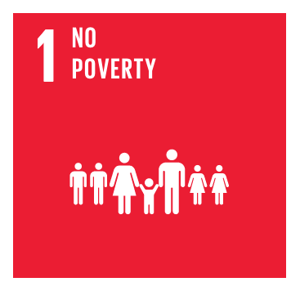 | End poverty in all its forms everywhere
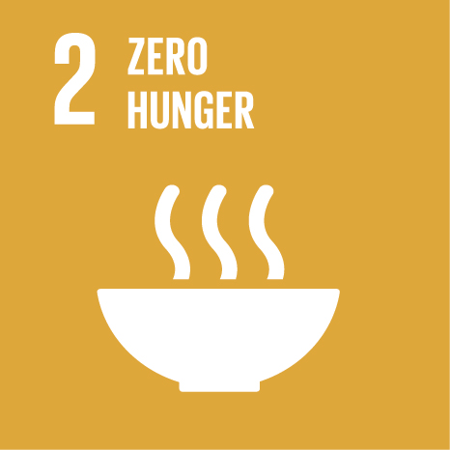 | End hunger, achieve food security and improved nutrition, and promote sustainable agriculture
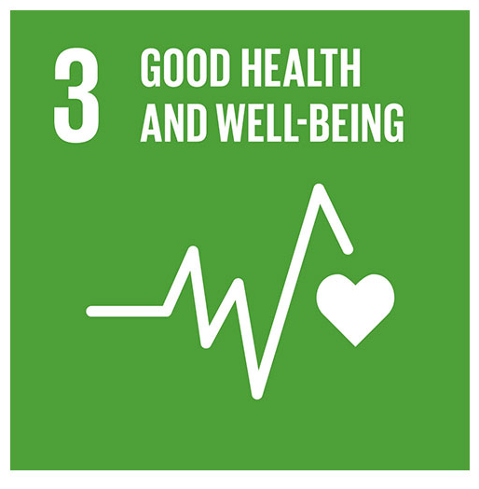 | Ensure healthy lives and promote wellbeing for all at all ages
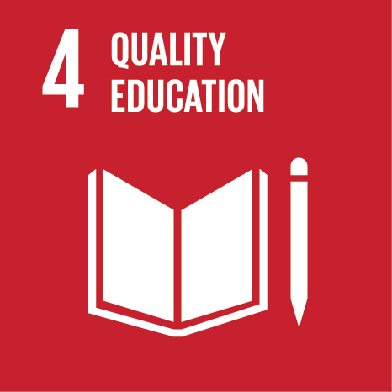 | Ensure inclusive and equitable quality education and promote lifelong learning opportunities for all
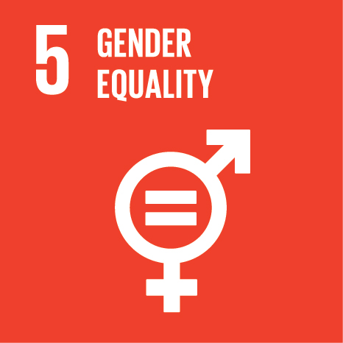 | Achieve gender equality and empower all women and girls
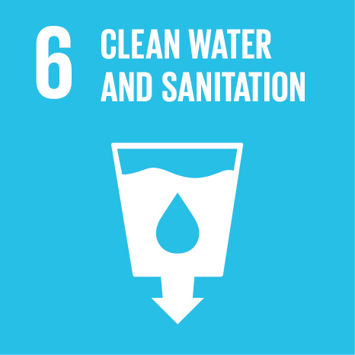 | Ensure availability and sustainable management of water and sanitation for all
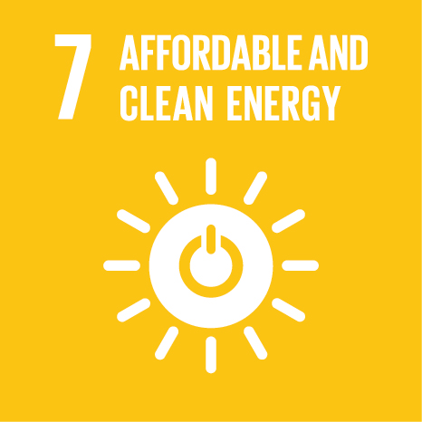 | Ensure access to affordable, reliable, sustainable and modern energy for all
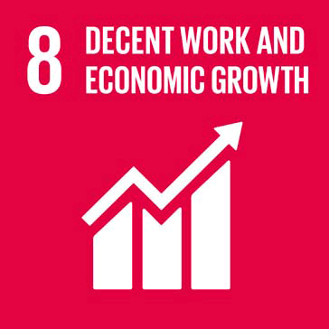 | Promote sustained, inclusive and sustainable economic growth, full and productive employment, and decent work for all
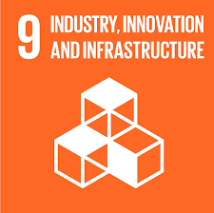 | Build resilient infrastructure, promote inclusive and sustainable industrialisation, and foster innovation
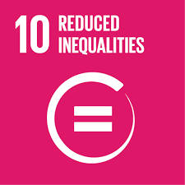 | Reduce inequality within and among countries
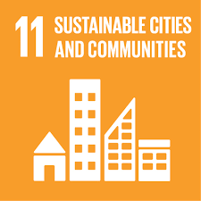 | Make cities and human settlements inclusive, safe, resilient and sustainable
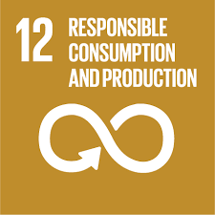 | Ensure sustainable consumption and production patterns
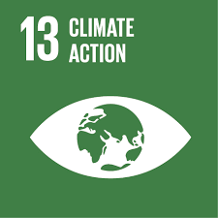 | Take urgent action to combat climate change and its impacts
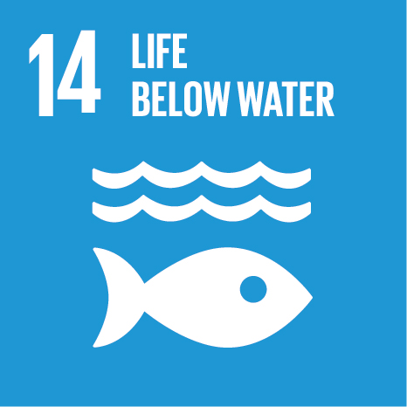 | Conserve and sustainably use the oceans, seas and marine resources for sustainable development
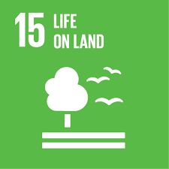 | Protect, restore and promote sustainable use of terrestrial ecosystems, sustainably manage forests, combat desertification and halt and reverse land degradation, and halt biodiversity loss
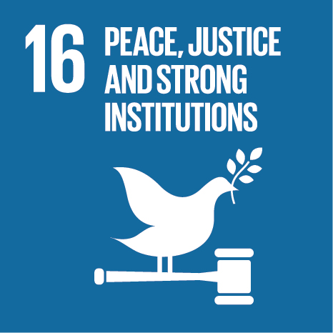 | Promote peaceful and inclusive societies for sustainable development, provide access to justice for all and build effective, accountable and inclusive institutions at all levels
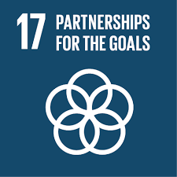 | Strengthen the means of implementation and revitalise the global partnership for sustainable development

